KKAO -

Functionality
The system calculates Work In Process (WIP) to determine the costs incurred for materials that have not yet been delivered to stock. This calculates the value of the unfinished goods.
In Product Cost by Order the work in process is calculated for the Manufacturing Order. The work in process for manufacturing orders is normally calculated at actual costs. Work in process at actual costs is calculated as the difference between the debits for material withdrawals, internal activity allocations, external activities, and overhead costs (that is, the Actual Costs assigned to the object) and the Actual Credits from goods receipts for delivery to stock.
The work in process can be transferred to Financial Accounting and Profit Center WIP = amount if only partial Goods Receipts has been performed.
WIP = 0 if only complete Goods Receipts has been performed.

Scenario
You want to calculated WIP either when Order is completed or at month end. WIP must be calculated when order is completed. In this case WIP =0. WIP must also be calculated at month end even though order is not completed. In this case WIP=amount.

Requirements
Partial or complete goods receipts was performed.

Menu Path | Accounting → Controlling → Product Cost Controlling → Cost Object Controlling → Product Cost by Order → Period-End Closing → Single Functions → Work in Process → Collective Processing → KKAO - Calculate
Transaction Code | KKAO

1. Double click on KKAO – Calculate.

Calculate Work in Process: Collective Processing

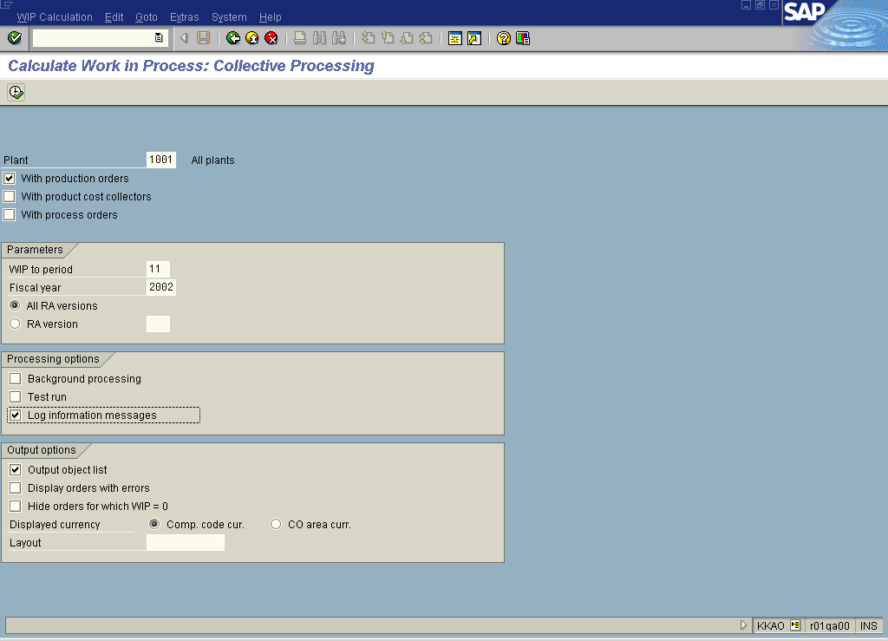

2. Update the following fields:

Field Name | Field Description | Values
Plant | Code identifying the operational unit of the company where the material is manufactured and stored. | Example: 1001
WIP to period | Number identifying a fiscal month to which cumulative WIP will be calculated. | Example: 11
Fiscal year | Fiscal year for which you calculate variance. | Example: 2002
3. Click the With product cost collectors checkbox to deselect.
4. Click the With process orders checkbox to deselect.
5. Click the All RA versions radio button.

6. Click the Test run checkbox to deselect.

7. Click the Log information messages checkbox to select.

8. Click the Execute button.

Calculate Work in Process: Object List

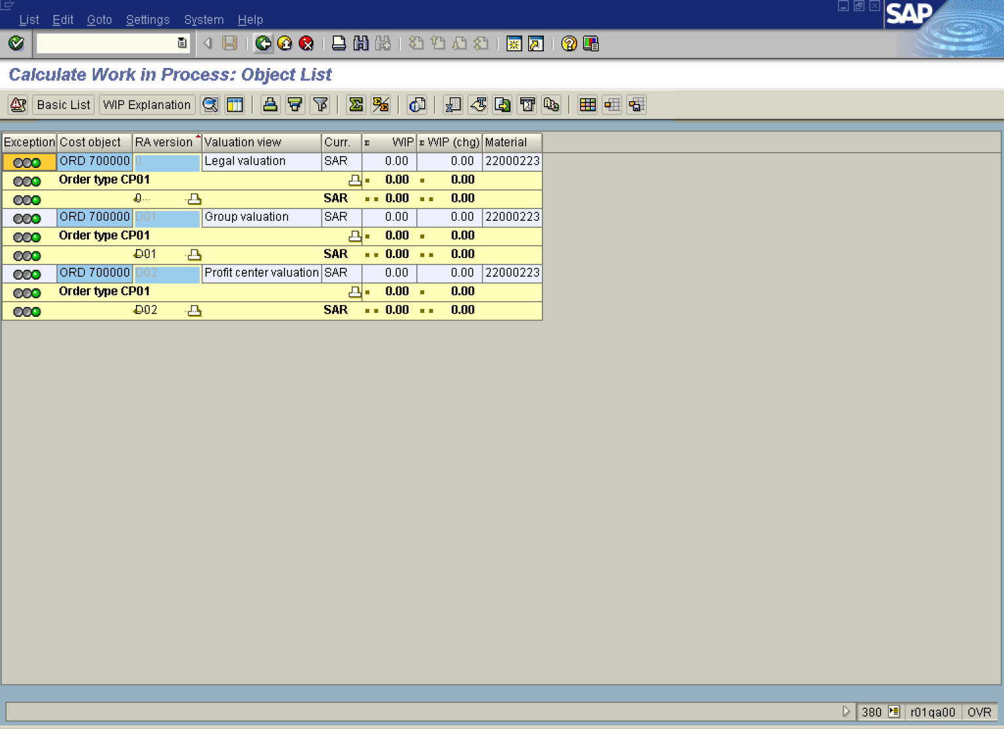

Note: The WIP results are presented per product cost collector per each valuation view, i.e. Legal or Profit Center Valuation View.

9. Click the Back button.

Exit list

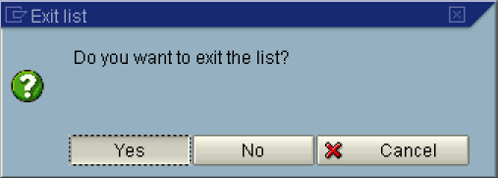

10. Click the Yes button.

